In week 9, the team kept working on updating the game. We made some changes to the game scene to have an interior look for the Bank office and Stock market office. Also the bodega interior had a new look.

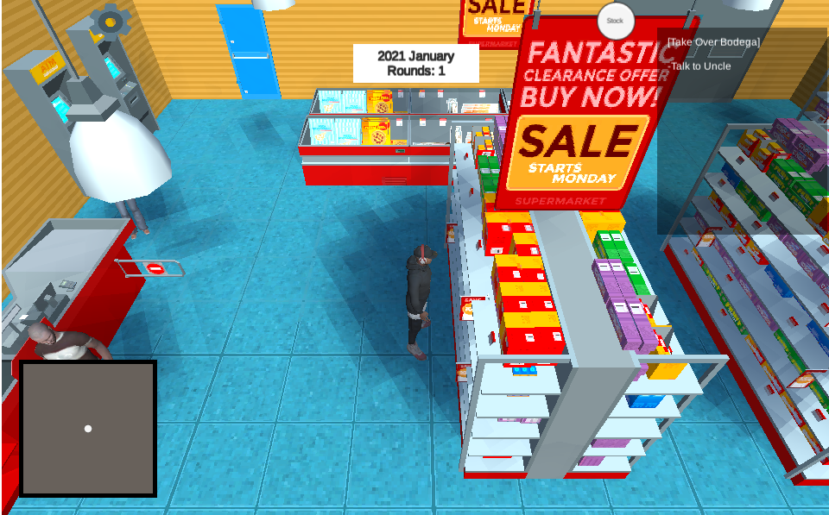

*Bodega interior*

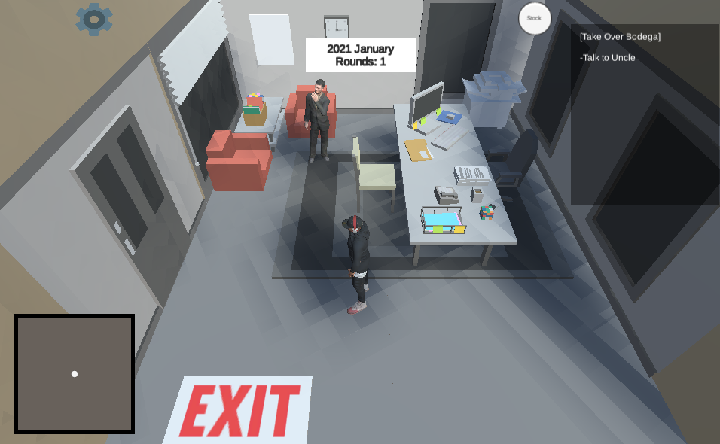

*Bank office*

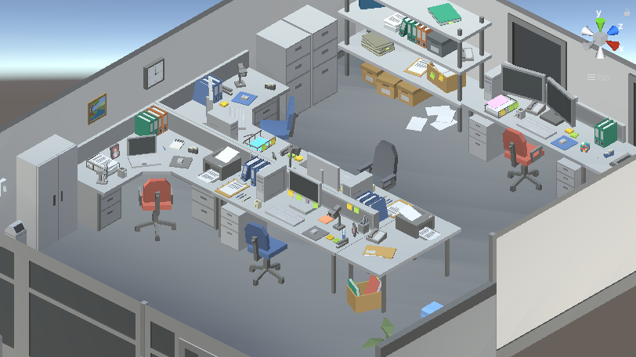

*Stock market*

We also updated the 2D portrait and character models.

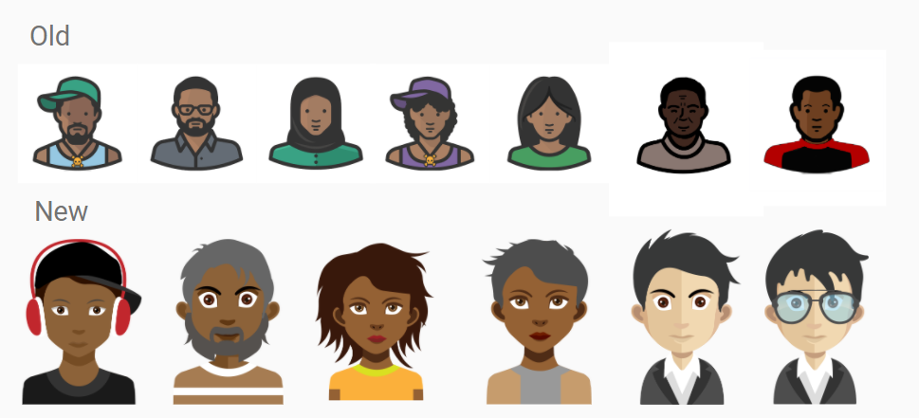

For the developing progress, last week we finalized all the story scripts with our client, and integrated some of them into the game. Now players are able to play through the game and experience the “Credit Card”, “Open bank account”, “Loan” story portions. We also start finalizing the game UI. Our artist also made a new navigation map for the game.

We still have some work to do for the following weeks. Here is the to-do list for the future works:

* NPC system, randomly set NPC positions at each round
* Music player
* Collectable items

The to-do list is ranked as priority. We will try our best to implement all of them.

We have already implemented all the basic game mechanisms and story flows. The rest part of our development is to polish our game and add more details. We are going to have another playtest next week, and we are looking forward to showing playtesters our updates.